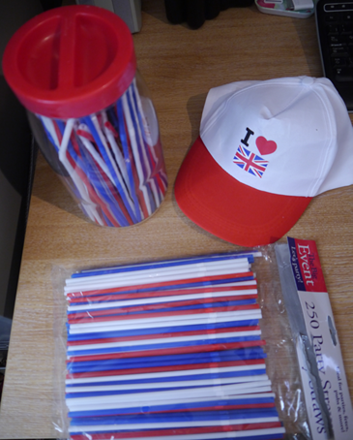
Background
This carousel of Jubilee tasks was hurriedly put together for a group of 10 E1-E3 Functional Maths and English 16-19 year old learners who had just (very successfully!) finished all their Edexcel Functional Skills assessments.
Most of the items were bought in Poundland.
- 250 straws £1, baseball cap £1, bunting and large flags (not illustrated) £1 per pack.
- Paper chains (Budgens) £2 (Note there were 40 sticky tabs per sheet, 4 x 10)
- Mini cupcakes (Waitrose) £1.49 for six.
Teacher's hat (!) and Estimate the number of straws in the jar. Remaining straws used for 2D shape work and fractions.

Lesson plan
- Introduction
- PPT – Queen’s family, palaces, etc. Many available on TES, I adapted this one from Nicky 510 at http://www.tes.co.uk/teaching-resource/The-Queen-s-Jubilee-Discussion-6218285/
- Then show parts of this YouTube video of the Queen’s Coronation
http://www.youtube.com/watch?v=LgJESiGkZus&feature=fvwrel
- Questioning (dates, numbers, family, etc.)
- Rest of session spent moving round in from one activity to another in pairs or threes. (See following pages)
- All results must be recorded properly.
- Finish as usual with diary sheets (and Jubilee cup cakes!)
- Prize (Jubilee headphones £1 Poundland) awarded by tutor at the end of session for the pair of students that have made the best effort and have recorded their answers carefully.

After a year of hard work from my students, the emphasis was on celebration and fun. However, learning objectives included: measuring, counting, writing an email, spelling, 2D shapes, estimating, rounding and working with money.
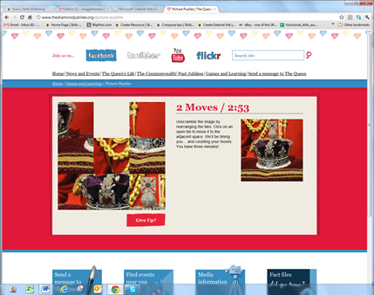
TABLE 1 (computer table)
PUZZLES and QUIZZES
Go to
http://www.thediamondjubilee.org/picture-puzzles

Name _____________
- Choose a slider puzzle
- Which number puzzle did you choose?
- What is the picture? ___________________________________
- How many moves? ____________________________________
- How long did it take you? _______________________________
Name _____________
- Choose a slider puzzle
- Which number puzzle did you choose?
- What is the picture? ___________________________________
- How many moves? ____________________________________
- How long did it take you? _______________________________
If you finish there are also some quizzes on this site.
http://www.thediamondjubilee.org/quizzes
TABLE 2 English
- How many words can you make from the words below?
- You can use a dictionary. You can use the letter cards to help you.
QUEEN’S DIAMOND JUBILEE

__________
__________
__________
__________
__________
__________
__________
__________
__________
__________
__________
__________
__________
__________
__________

- Write an email of congratulations to the Queen. Write at least 3 sentences.
- Tell her what you will be doing to celebrate her jubilee.

From... You (yourname@youmail.co.uk)
To… The Queen Hermajesty@buck.pal.uk

Subject: Congratulations
_________________________________________________________
_________________________________________________________
_________________________________________________________
_________________________________________________________
_________________________________________________________
_________________________________________________________
TABLE 3 Maths
Paper chains

- There are sheets of sticky tabs to stick the chains together.
How many sticky tabs on one sheet? ____________
- Show a quick way of working this out without counting them all _________
- How long and wide is one coloured strip of paper? _____cm x ____cm
- Make a paper chain that is 3m long.
- Use the different colour strips to make a repeating regular pattern.
Describe your pattern:
___________________________________________________________
- Check the length with a measuring tape.
- Please write your names on the paper chain.
- Then complete this table.
red | blue | white | Union Jack | Total no. strips

- Hang up your paper chain.
TABLE 4 Maths - Straws
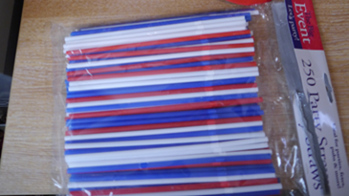
You will need
Scissors – snip the top of each straw to make a point. This helps one straw fit inside another. Use the bendy bit of the straw to make the corners of shapes.
Sellotape – you can use this to keep the straws together if needed

- Measure the length of one straw to the nearest cm. _______
- Cut one straw into quarters. Sellotape the pieces to this sheet.

- Cut a different coloured straw into thirds and stick to this sheet.

- Use three whole straws to make a triangle.
- Make another 2D shape with the straws.
- How many straws do you need to make a line 1 metre long?
- Estimate the number of straws in the bottle.
Name __________________

Name ___________________

TABLE 5 Maths
Jubilee cup cakes
- Use the till receipt to find the cost of one pack of 6 mini cupcakes. £________
- Round the cost to the nearest 10p ____________
- Use the rounded cost to work out the cost of one cup cake.
Show your working out. You can use a calculator.

One cake costs __________________
- How many calories in one cake?
- How many calories in one pack of cakes?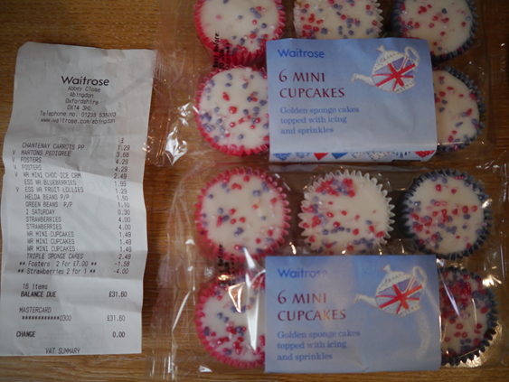
- What else did I buy at Waitrose? List 3 items ______________________

